Vancouver Female Ice Hockey Association (VFIHA)
Call for Proposal to Musqueam, Squamish and Tsleil-Waututh Nations’ Artists
Indigenous Jersey Crest

Applicants: Musqueam, Squamish and Tsleil-Waututh Nations’ female-identifying and two-spirited artists.
Scope: To create an Indigenous crest design for VFIHA team jerseys. The crest design must be an animal or creature (of the land, water, sky and/or spirit). The design is to be connected to the culture and stories of the artist’s nation. The selected artist will provide a written explanation of their design, which will be shared on the VFIHA website.
Purpose: To celebrate and share Indigenous culture through the design of the artist’s nation. The design and accompanying explanation is a means to educate the members of VFIHA on the culture of the artist’s nation and create an opportunity to create a bridge between the association and the First Nation.
Critical Dates (refer to “VFIHA Indigenous Jersey Crest Design Selection Process”):
- Stage 1: Final Date for Receipt of Applications: Saturday, June 11, 2022
- Stage 2: Short List of Artists: Saturday June 18, 2022
- Stage 3: Develop Concept Design with Short List of Artists: Final drafts by Saturday, July 16, 2022
- Stage 4: Completion of Selection Process: Saturday July 30, 2022
- Stage 5: Design Process Schedule: To be determined with selected artist and VFIHA Board

Please note that the VFIHA Board may amend the above dates.
Background: Mid 2021 the BC Hockey Indigenous Participation Work Group encouraged local minor hockey associations to appoint an Indigenous Liaison Person who would initiate and assist with the building of quality relationships with their local First Nation(s). Due to the high level of interest in this position, the VFIHA created an Indigenous Liaison Committee to share in this role. The creation of a jersey crest is a way to celebrate and collaborate with the hosting First Nations.
Design Details:
- Crest should represent an animal or creature as per Scope above.
- Crest should be large on the front of the jersey, with recognition from a distance being a priority.
- Primary colours should be the same as current colours (maroon, gold, black/white) - CMYK:
o Gold (Sub 122 - 0,17,80,0)
o Maroon (Sub 229 - 0,100,15,60)
o Dark (Sub 5195 - 72,90,75,15)
- Final design must be in a CMYK vector format that we can use for jersey sublimation process (https://www.graphicdet.com/blog/understanding-file-types/ ).
- The following file formats of the design will also be required: .ai, .eps, .png and .jpeg.

Copyright:

- Artist retains copyright
- Vancouver Female Ice Hockey Association is granted exclusive and perpetual rights for use in all formats and media.
- vfiha.com will dedicate a webpage to the artist and the design, including the artist’s description of the cultural significance of the design.

Before you apply, please email indigenous-liason@vfiha.com to let us know to expect your application.
Current VFIHA Jersey:
Home Jersey:
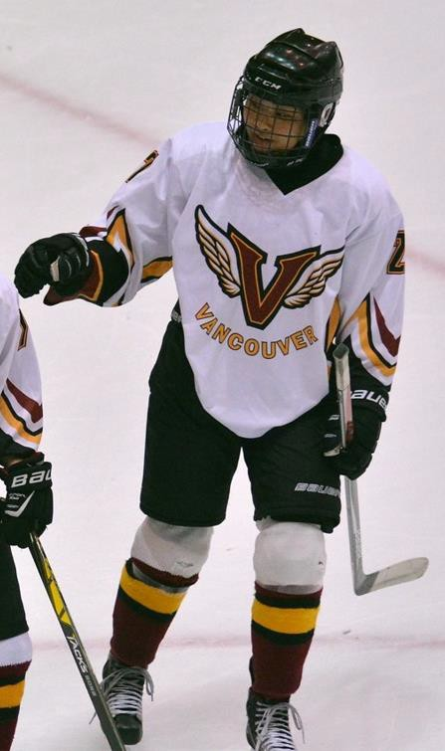

Away Jersey:
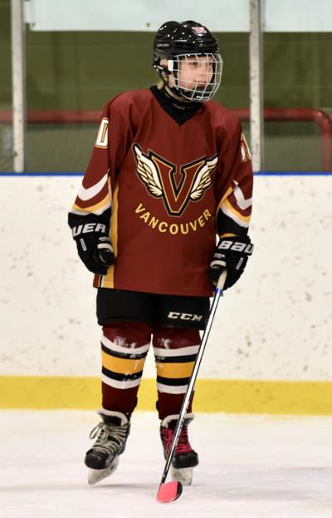

VFIHA Indigenous Jersey Crest Design Application Form:
Please submit to indigenous-liason@vfiha.com by June 11th, 2022. Decision on selection of artist and the design resides solely with the Vancouver Female Ice Hockey Association Board.
Name:
Email Address:
First Nation you belong to:
Your Artistic Website:
Public Profile (social media):
Preferred Communication Form (email, text, etc.):
Fee for Usage as per “Copyright” above:
Achievement and Awards:
Initial Thoughts on the Crest Design (sketch and/or text description):

100 Words (approx.) about your connection to hockey and to Vancouver:

Minimum Two References (can be elders, fellow artists, teachers, clients):
Name and contact details

Please attach the following with this application:
- Profile Photo (optional)
- Artist Resume (include up to 6 photos of artform to illustrate your different artworks that are applicable to the scope of this Call for Proposal. Include experience in artform.

